BIO INSPIRED SYSTEMS LAB EXPERIMENT

Title: Graph Coloring using Ant Colony Optimization

Code:

import random
import numpy as np

class GraphColoringACO:
def __init__(self, adjacency_list, num_ants=20, num_colors=10, alpha=1, beta=3,
rho=0.1, Q=1.0, max_iter=100, print_interval=10):
"""
Initialize the ACO parameters and the graph.
adjacency_list: dict {node: [neighbors]}
"""
self.graph = adjacency_list
self.nodes = list(adjacency_list.keys())
self.num_nodes = len(self.nodes)

self.num_ants = num_ants
self.num_colors = num_colors
self.alpha = alpha
self.beta = beta
self.rho = rho
self.Q = Q
self.max_iter = max_iter
self.print_interval = print_interval

self.pheromone = np.ones((self.num_nodes, num_colors))

self.heuristic = np.zeros((self.num_nodes, num_colors))
for v in range(self.num_nodes):
degree = len(adjacency_list[v])
h = 1 / (1 + degree)
self.heuristic[v, :] = h

self.best_coloring = None
self.best_conflicts = float('inf')
self.best_colors_used = float('inf')

def _calculate_conflicts(self, coloring):
"""Count number of color conflicts."""
conflicts = 0
for u in self.graph:
for v in self.graph[u]:
if coloring[u] == coloring[v]:
conflicts += 1
return conflicts // 2

def _colors_used(self, coloring):
"""Return how many colors are actually used."""
return len(set(coloring.values()))

def _construct_solution(self):
"""Construct coloring for one ant."""
coloring = {}
nodes = self.nodes[:]
random.shuffle(nodes)

for v in nodes:
probabilities = []
for c in range(self.num_colors):
conflict = any(coloring.get(nbr) == c for nbr in self.graph[v])
if conflict:
prob = 0.0
else:
tau = self.pheromone[v][c] ** self.alpha
eta = self.heuristic[v][c] ** self.beta
prob = tau * eta
probabilities.append(prob)

total = sum(probabilities)
if total == 0:
color = random.randint(0, self.num_colors - 1)
else:
probs = [p / total for p in probabilities]
color = random.choices(range(self.num_colors), weights=probs)[0]

coloring[v] = color

return coloring

def _update_pheromone(self, ants_solutions):
"""Update pheromone based on solutions."""
self.pheromone *= (1 - self.rho) # evaporation

for coloring, conflicts, colors_used in ants_solutions:
if conflicts == 0: # reward only valid colorings
deposit = self.Q / colors_used
for v, c in coloring.items():
self.pheromone[v][c] += deposit

def run(self):
"""Run the ACO algorithm."""
for iteration in range(1, self.max_iter + 1):
ants_solutions = []
for _ in range(self.num_ants):
coloring = self._construct_solution()
conflicts = self._calculate_conflicts(coloring)
colors_used = self._colors_used(coloring)
ants_solutions.append((coloring, conflicts, colors_used))

if (conflicts < self.best_conflicts) or \
(conflicts == 0 and colors_used < self.best_colors_used):
self.best_coloring = coloring
self.best_conflicts = conflicts
self.best_colors_used = colors_used

self._update_pheromone(ants_solutions)

if iteration % self.print_interval == 0 or iteration == 1 or iteration == self.max_iter:
print(f"Iter {iteration}/{self.max_iter} | "
f"Best Conflicts: {self.best_conflicts}, Colors Used: {self.best_colors_used}")

if self.best_conflicts == 0:
print(f"Perfect coloring found at iteration {iteration}!")
break

return self.best_coloring, self.best_colors_used, self.best_conflicts

if __name__ == "__main__":
# Harder graph: 10 nodes, moderately dense connections
graph = {
0: [1, 2, 3, 4],
1: [0, 2, 5, 6],
2: [0, 1, 3, 6, 7],
3: [0, 2, 4, 7, 8],
4: [0, 3, 8, 9],
5: [1, 6, 9],
6: [1, 2, 5, 7, 9],
7: [2, 3, 6, 8],
8: [3, 4, 7, 9],
9: [4, 5, 6, 8]
}
aco = GraphColoringACO(graph, num_ants=30, num_colors=3, max_iter=100, print_interval=10)
best_coloring, colors_used, conflicts = aco.run()

print("\nBest Coloring Found:")
print(best_coloring)
print(f"\nColors Used: {colors_used}, Conflicts: {conflicts}")

Output:
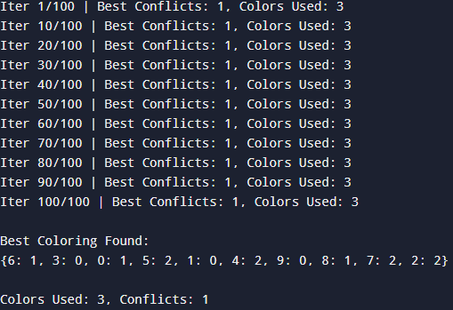

Done by: Nishanth S Padigar
1BM23CS215
5D

